***Exp 3***

*Aryaman Gautam*

*J001*

1. Alternately turn ON / OFF the BUZZER

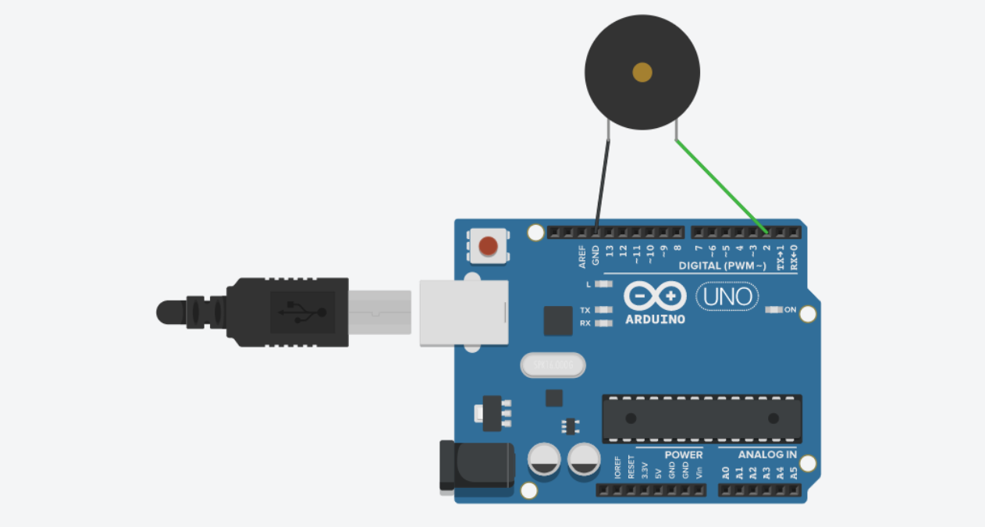

void setup()

{

pinMode(2, OUTPUT);

}

void loop()

{

tone(2, 512);

delay(1000); // Wait for 1000 millisecond(s)

noTone(2);

delay(1000); // Wait for 1000 millisecond(s)

}

1. Blink LED without using delay

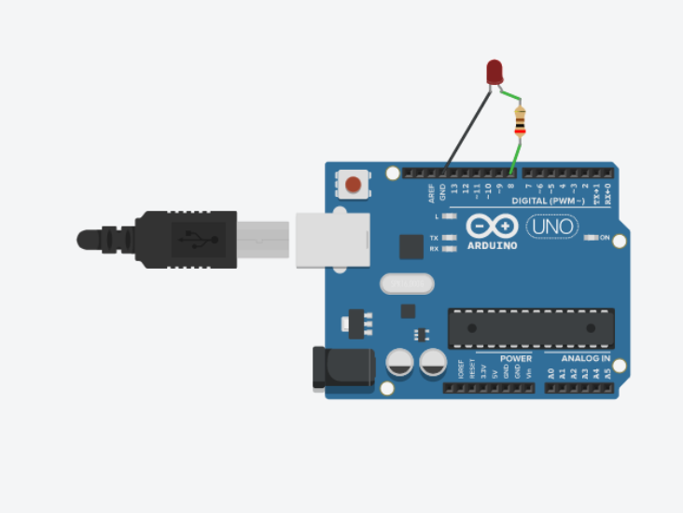

void setup()

{

pinMode(13, OUTPUT);

}

void loop()

{

digitalWrite(13, HIGH);

delay(1000); // Wait for 1000 millisecond(s)

digitalWrite(13, LOW);

delay(1000); // Wait for 1000 millisecond(s)

}

1. Demonstrate the use of input pull up

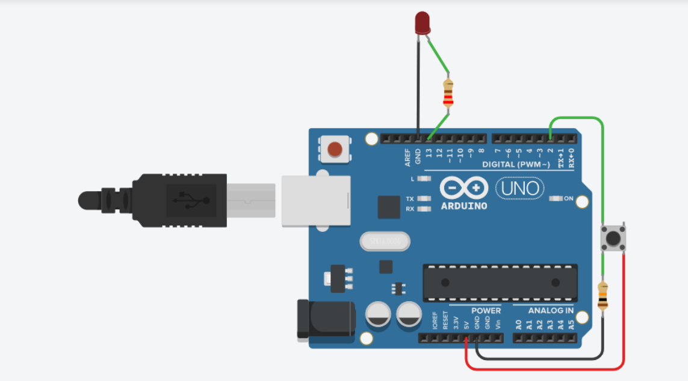

//int buttonState = 0;

void setup()

{

pinMode(2, INPUT_PULLUP);// usually 1 , push..0 pullup: inverted of input

pinMode(13, OUTPUT);

Serial.begin(9600);

}

void loop()

{

// read the input pin

int buttonState = digitalRead(2);

// print out the state of the button

digitalWrite(13, buttonState);

Serial.println(buttonState);

delay(1000);

}

1. Traffic signal using RGB

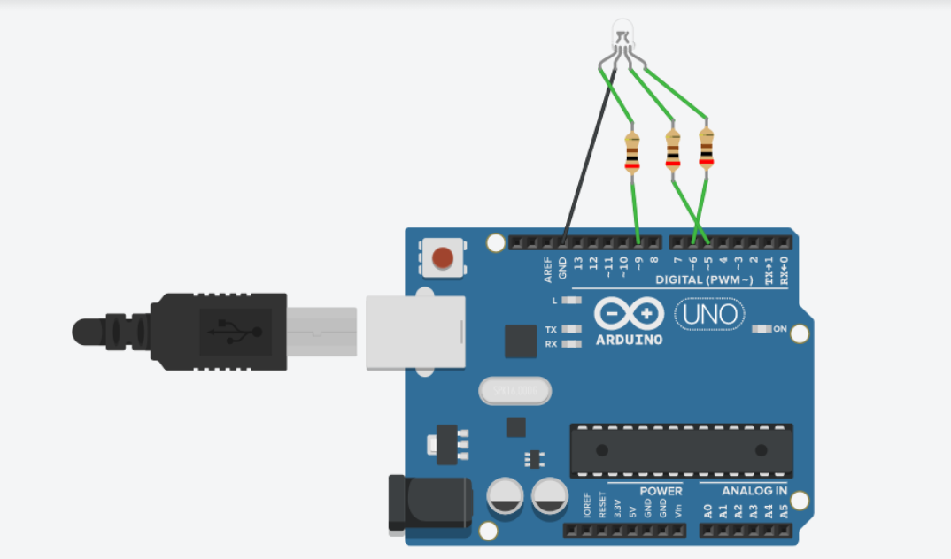

int pos = 0;

void setup()

{

pinMode(9, OUTPUT);// red

pinMode(6, OUTPUT);// green

pinMode(5, OUTPUT);// blue

}

void loop()

{

digitalWrite(9, HIGH);

delay(500);

digitalWrite(6, LOW);

delay(500);

digitalWrite(5, LOW);

delay(500);

digitalWrite(9, LOW);

delay(500);

digitalWrite(6, HIGH);

delay(500);

digitalWrite(5, LOW);

delay(500);

digitalWrite(9, LOW);

delay(500);

digitalWrite(6, LOW);

delay(500);

digitalWrite(5, HIGH);

delay(500);

}

1. Control tone of buzzer with potentiometer

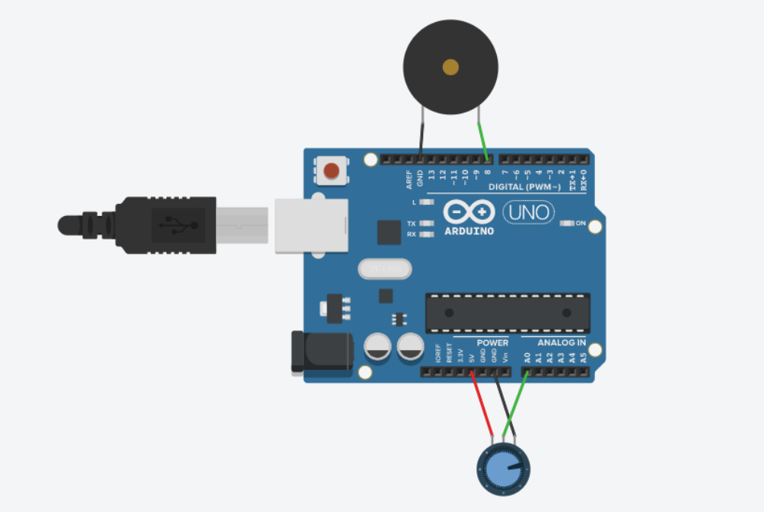

int sensorValue = 0;

void setup()

{

pinMode(A0, INPUT);

pinMode(8, OUTPUT);

Serial.begin(9600);

}

void loop()

{

// read the input on analog pin 0:

sensorValue = analogRead(A0);

tone(8, sensorValue);

// print out the value you read:

Serial.println(sensorValue);

delay(10); // Delay a little bit to improve simulation performance

}

1. Play a tune when button is pressed

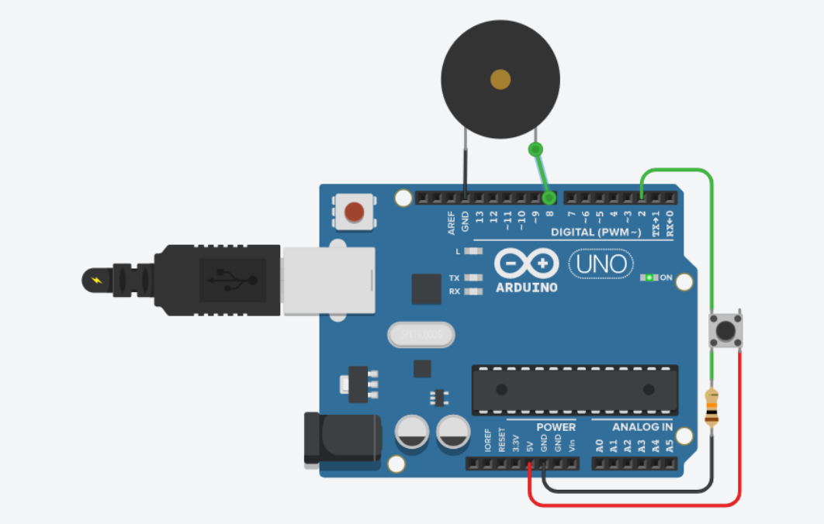

/*

DigitalReadSerial

Reads a digital input on pin 2, prints the

result to the serial monitor

This example code is in the public domain.

*/

int buttonState = 0;

void setup()

{

pinMode(2, INPUT);

pinMode(8, OUTPUT);

}

void loop()

{

// read the input pin

buttonState = digitalRead(2);

if(buttonState == 1)

{

tone(8,440);

delay(500);

noTone(8);

}

}

1. Traffic signal with a buzzer

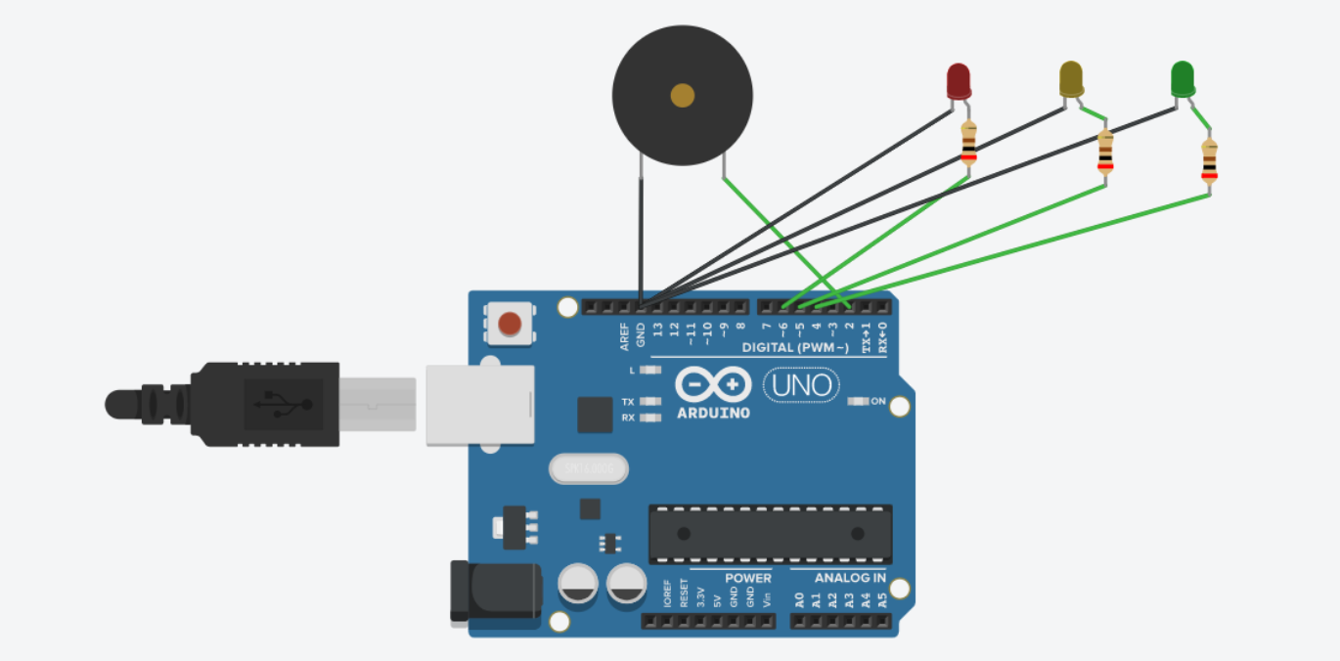

void setup()

{

pinMode(4, OUTPUT); // green

pinMode(5, OUTPUT); //yellow

pinMode(6, OUTPUT); //red

pinMode(2, OUTPUT); //buzzer

}

void loop()

{

digitalWrite(6, HIGH);

delay(5000);

digitalWrite(6, LOW);

tone(2, 440);

delay(2000);

noTone(2);

for (int i=0; i<5; i++){

digitalWrite(5, HIGH);

delay(500);

digitalWrite(5, LOW);

delay(500);

}

digitalWrite(4, HIGH);

delay(5000);

digitalWrite(4, LOW);

tone(2, 440);

delay(2000);

noTone(2);

}